**Carro con alarma**

1. Funcionamiento

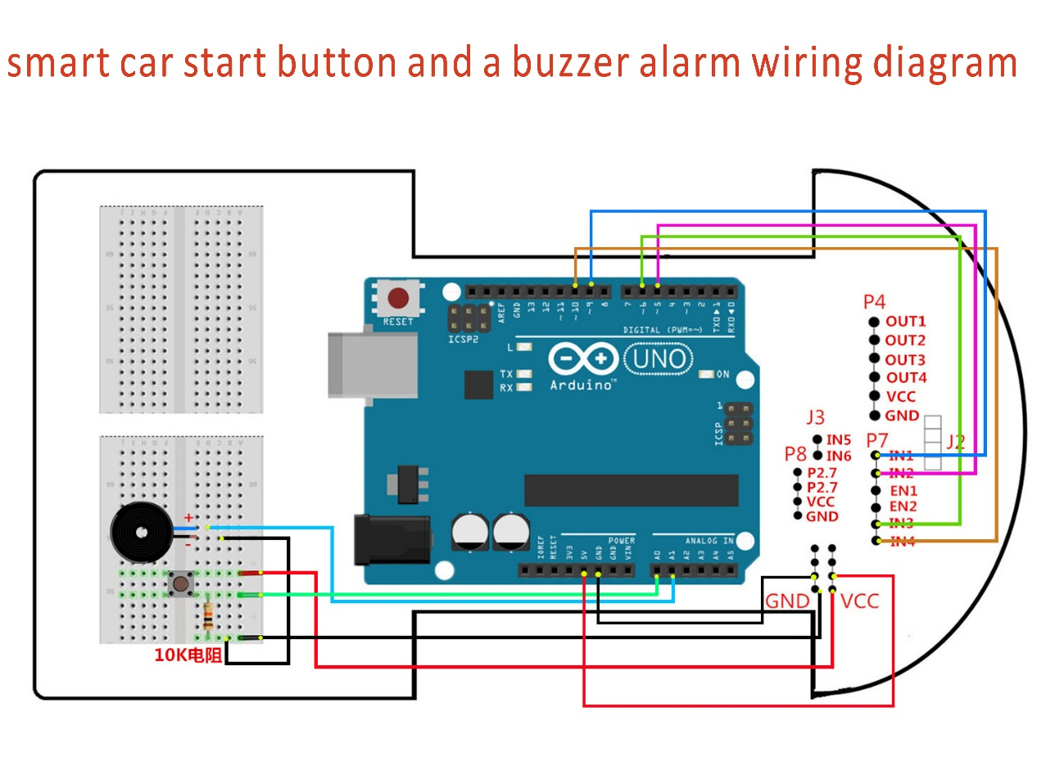

1. Código

int Left_motor_back=8; //(IN1)

int Left_motor_go=9; //(IN2)

int Right_motor_go=10; //(IN3)

int Right_motor_back=11; //(IN4)

//Buzzer

int key=A0;

int beep=A1;

int estado=0;

int valAnt = 0;

void setup()

{

Serial.begin(9600);

pinMode(Left_motor_go,OUTPUT);

pinMode(Left_motor_back,OUTPUT);

pinMode(Right_motor_go,OUTPUT);

pinMode(Right_motor_back,OUTPUT);

pinMode(key,INPUT);

pinMode(beep,OUTPUT);

}

void run(int time)

{

keysacn();

digitalWrite(Right_motor_go,HIGH);

digitalWrite(Right_motor_back,LOW);

analogWrite(Right_motor_go,200);

analogWrite(Right_motor_back,0);

digitalWrite(Left_motor_go,HIGH);

digitalWrite(Left_motor_back,LOW);

analogWrite(Left_motor_go,200);

analogWrite(Left_motor_back,0);

delay(time * 100);

}

void brake(int time)

{

keysacn();

digitalWrite(Right_motor_go,LOW);

digitalWrite(Right_motor_back,LOW);

digitalWrite(Left_motor_go,LOW);

digitalWrite(Left_motor_back,LOW);

delay(time * 100);

}

void left(int time)

{

keysacn();

digitalWrite(Right_motor_go,HIGH);

digitalWrite(Right_motor_back,LOW);

analogWrite(Right_motor_go,200);

analogWrite(Right_motor_back,0);

digitalWrite(Left_motor_go,LOW);

digitalWrite(Left_motor_back,LOW);

analogWrite(Left_motor_go,0);

analogWrite(Left_motor_back,0);

delay(time * 100);

}

void spin_left(int time)

{

keysacn();

digitalWrite(Right_motor_go,HIGH);

digitalWrite(Right_motor_back,LOW);

analogWrite(Right_motor_go,200);

analogWrite(Right_motor_back,0);

digitalWrite(Left_motor_go,LOW);

digitalWrite(Left_motor_back,HIGH);

analogWrite(Left_motor_go,0);

analogWrite(Left_motor_back,200);

delay(time * 100);

}

void right(int time)

{

keysacn();

digitalWrite(Right_motor_go,LOW);

digitalWrite(Right_motor_back,LOW);

analogWrite(Right_motor_go,0);

analogWrite(Right_motor_back,0);

digitalWrite(Left_motor_go,HIGH);

digitalWrite(Left_motor_back,LOW);

analogWrite(Left_motor_go,200);

analogWrite(Left_motor_back,0);

delay(time * 100);

}

void spin_right(int time)

{

keysacn();

digitalWrite(Right_motor_go,LOW);

digitalWrite(Right_motor_back,HIGH);

analogWrite(Right_motor_go,0);

analogWrite(Right_motor_back,200);

digitalWrite(Left_motor_go,HIGH);

digitalWrite(Left_motor_back,LOW);

analogWrite(Left_motor_go,200);

analogWrite(Left_motor_back,0);

delay(time * 100);

}

void back(int time)

{

keysacn();

digitalWrite(Right_motor_go,LOW);

digitalWrite(Right_motor_back,HIGH);

analogWrite(Right_motor_go,0);

analogWrite(Right_motor_back,150);

digitalWrite(Left_motor_go,LOW);

digitalWrite(Left_motor_back,HIGH);

analogWrite(Left_motor_go,0);

analogWrite(Left_motor_back,150);

delay(time * 100);

}

void keysacn()

{

int val;

val=digitalRead(key);

Serial.println(val);

if(val==HIGH && valAnt==LOW){

estado = 1-estado;

}

if(estado==1){

digitalWrite(beep,HIGH);

}

else{

digitalWrite(beep,LOW);

}

valAnt = val;

}

void loop()

{

back(10);

brake(5);

run(10);

brake(5);

left(10);

right(10);

spin_left(20);

spin_right(20);

brake(5);

}